Introduction

The Entity Framework is an Object Relational Mapping (ORM) providing an automated mechanism for CRUD operations to a database.

Entity Framework provides various approaches.

* Database first
* Code First

This article explains the Code First approach. This is mainly used for domain-driven development. Initially, we are not focusing on the database development, so we are creating classes instead of tables in the database. Based on these classes we can simply create our database.

A quick start

**Step 1.**Create a console application.

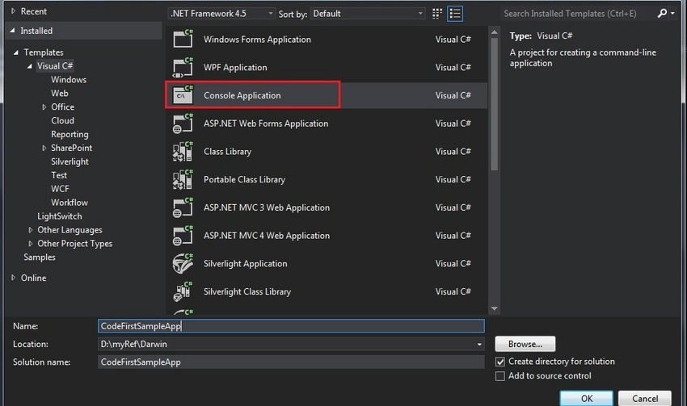

**Step 2.**Add a new class.

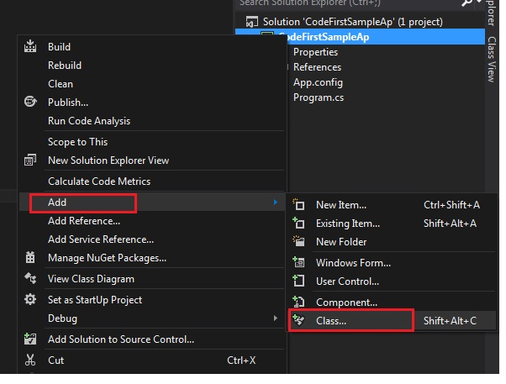

**Step 3.**Class name as Employee.

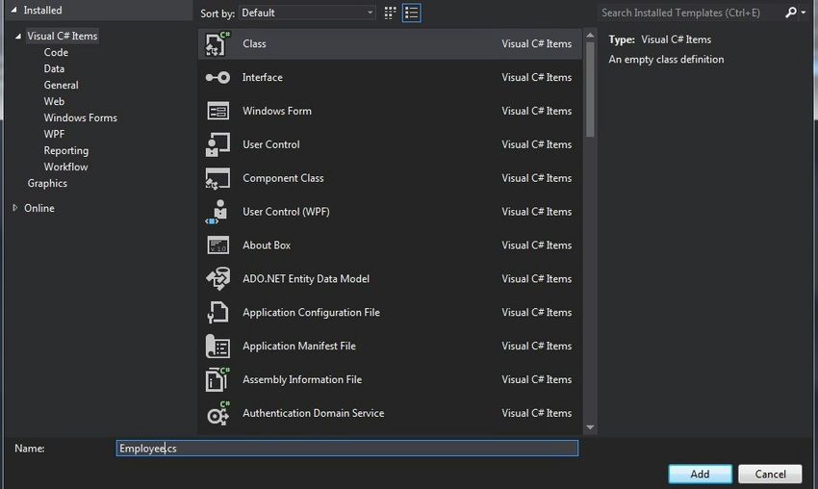

**Step 4.**Write the field names in the Employee table (consider this Employee class is your Employee Table).

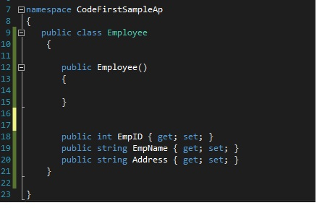

**Step 5.**Go to the project References => Manage NuGet Packages.

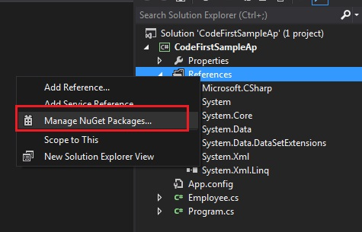

**Step 6.**Install EntityFramework.

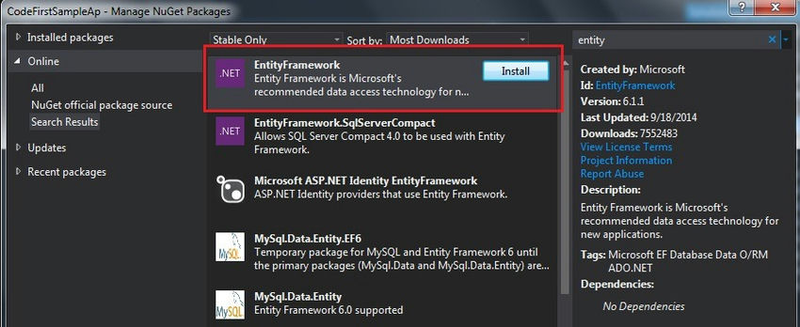

**Step 7.** Return to our Employee class and add the reference.

using System.ComponentModel.DataAnnotations;

ComponentModel.DataAnnotations

Provides attribute classes to define metadata for ASP.NET MVC and ASP.NET data controls.

[System.ComponentModel.DataAnnotations Namespace](http://msdn.microsoft.com/en-us/library/system.componentmodel.dataannotations.aspx).

Some examples

* Table
* Table Name
* Column
* Column name
* Key
* PK for the table
* ForeignKey
* FK Relation
* Required
* Required field validation
* MinLength
* Min length of the field
* MaxLength
* Max Length

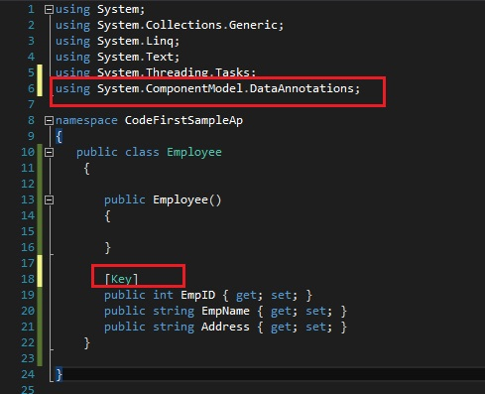

using System;

using System.Collections.Generic;

using System.Linq;

using System.Text;

using System.Threading.Tasks;

using System.ComponentModel.DataAnnotations;

namespace CodeFirstSampleAp

{

public class Employee

{

public Employee()

{

}

[Key]

public int EmpID { get; set; }

public string EmpName { get; set; }

public string Address { get; set; }

}

}

Add a new class MyContext and inherit the DbContext with a "using" for the reference as in the following.

using System.Data.Entity

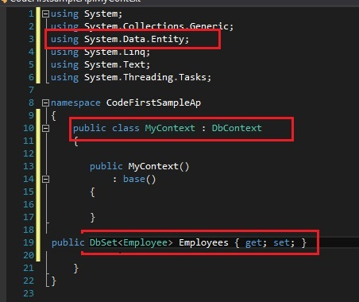

Next, we need to plan where we need to create our database. So in the app config create our connection string.

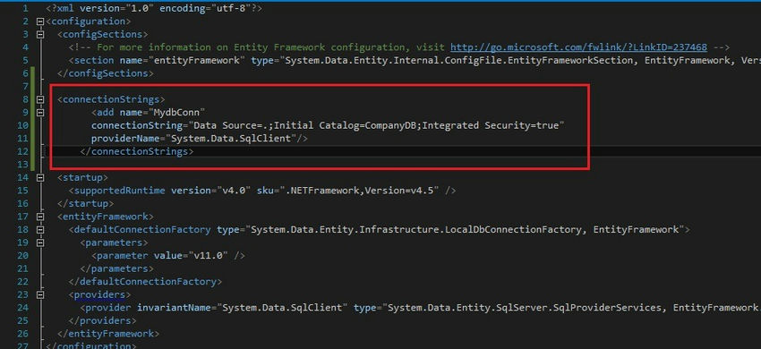

<connectionStrings>

<add name="MydbConn"

connectionString="Data Source=.;Initial Catalog=CompanyDB;Integrated Security=true"

providerName="System.Data.SqlClient"/>

</connectionStrings>

XML

Then return to our MyContext class and pass our connection details here.

Also, we can plan our database Initializer. That means all the time we don't want to create a new database. Based on our requirements we can plan this.

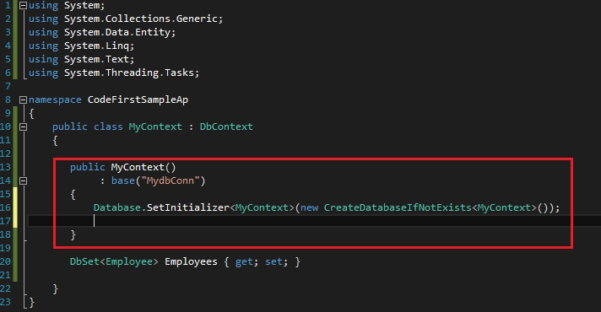

using System;

using System.Collections.Generic;

using System.Data.Entity;

using System.Linq;

using System.Text;

using System.Threading.Tasks;

namespace CodeFirstSampleAp

{

public class MyContext : DbContext

{

public MyContext()

: base("MydbConn")

{

Database.SetInitializer<MyContext>(new CreateDatabaseIfNotExists<MyContext>());

}

public DbSet<Employee> Employees { get; set; }

}

}

More options for the database Initializer.

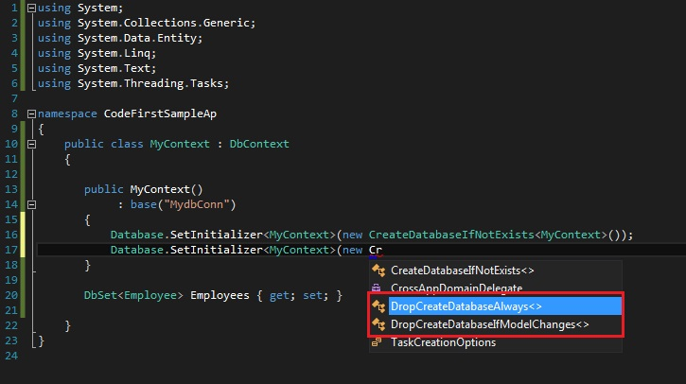

Suppose we are working with a production db, so we can prevent or turn off this feature.

Database.SetInitializer<MyContext>(null);

Next, go to the main and add a value to our new table.

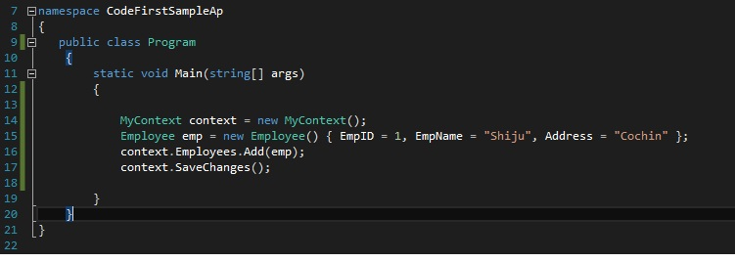

using System;

using System.Collections.Generic;

using System.Linq;

using System.Text;

using System.Threading.Tasks;

namespace CodeFirstSampleAp

{

public class Program

{

static void Main(string[] args)

{

MyContext context = new MyContext();

Employee emp = new Employee() { EmpID = 1, EmpName = "Shiju", Address = "Cochin" };

context.Employees.Add(emp);

context.SaveChanges();

}

}

}

Yes! Our Code First application is completed.

Go to our db. It automatically created the new db name CompanyDB that we specified in the AppConfig file.

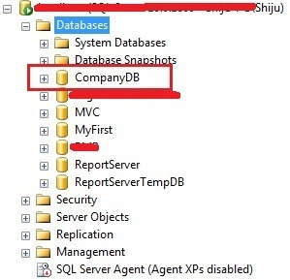

Check whether the table has our inserted value.

